Step 1: Install/Verify Ultralytics
!pip install ultralytics
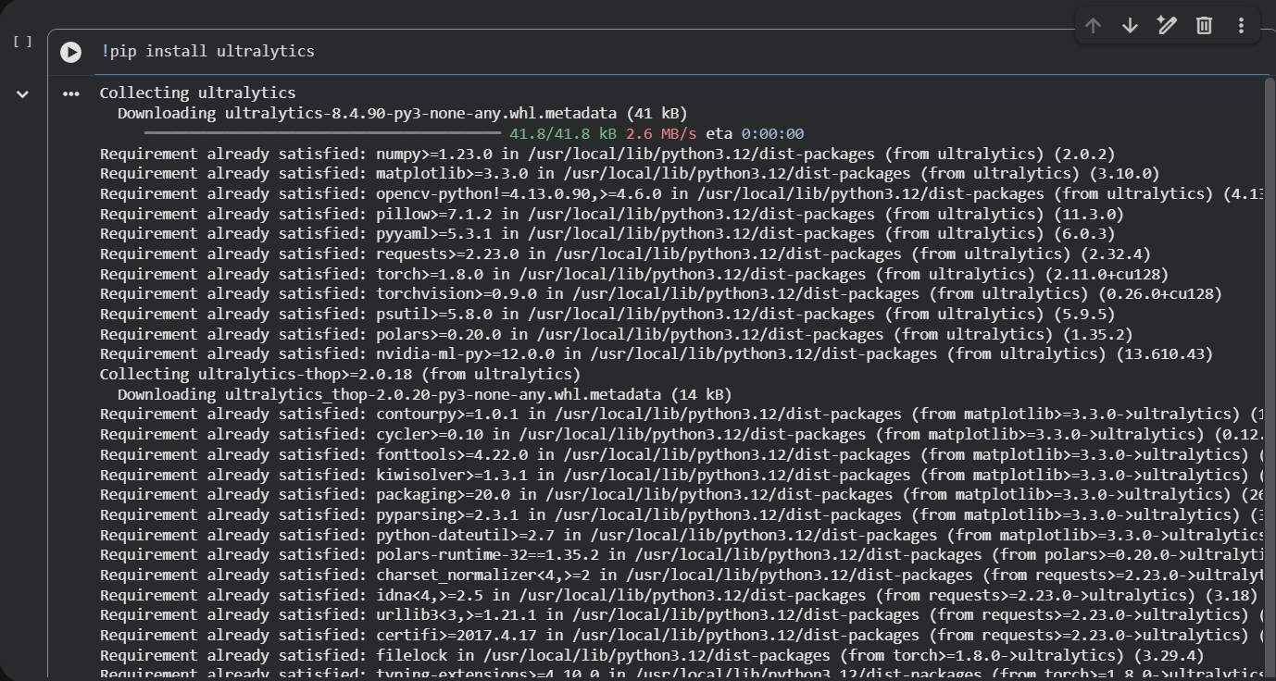
Step 2: Mount Google Drive
drive.mount('/content/drive')
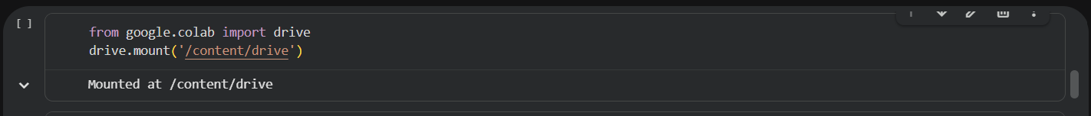
Step 3: Run the YOLOv8 Training Command
!yolo detect train model=yolov8s.pt data=/content/drive/MyDrive/Dataset/secure_vision/data.yaml epochs=54 imgsz=740 project=/content/drive/MyDrive/SecureVision_Model name=yolov8_weapons_model
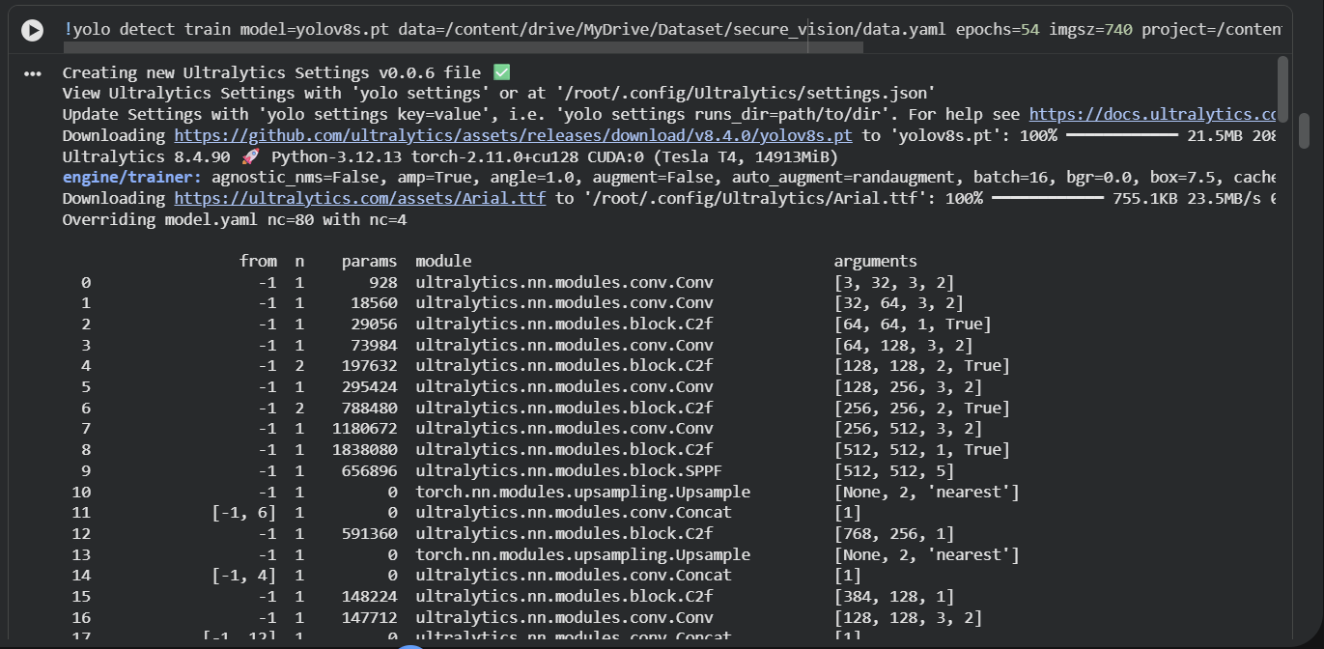
Step 4: Run the YOLOv11 Training Command
!yolo detect train model=yolo11s.pt data=/content/drive/MyDrive/Dataset/secure_vision/data.yaml epochs=54 imgsz=740 project=/content/drive/MyDrive/SecureVision_Model name=yolo11_weapons_model
